HR Analytics SQL PROJECT

Top Rows:
SELECT TOP 5 * FROM HRDATA;
Employee Count:
select sum(employee_count) as Employee_Count from hrdata;
Attrition Count:
select count(attrition) from hrdata where attrition='Yes';
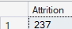
Attrition Rate:
select
round (((select count(*) from hrdata where attrition='yes') * 100.0 /
sum(employee_count)), 2) as attrition_rate
from hrdata;
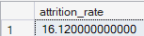
Active Employee:
select sum(employee_count) - (select count(attrition) from hrdata where attrition='Yes') from hrdata;
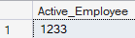
Average Age:
select round(avg(age),0) as Avg_Age from hrdata;
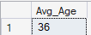
Attrition by Gender
select gender, count(attrition) as attrition_count from hrdata
where attrition='Yes'
group by gender
order by count(attrition) desc;
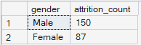
Department wise Attrition:
select department, count(attrition) as Attrition_count, round((cast (count(attrition) as numeric) /
(select count(attrition) from hrdata where attrition= 'Yes')) * 100, 2) as pct from hrdata
where attrition='Yes'
group by department
order by count(attrition) desc;
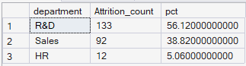
No of Employee by Age Group
SELECT age, sum(employee_count) AS employee_count FROM hrdata
GROUP BY age
order by age;
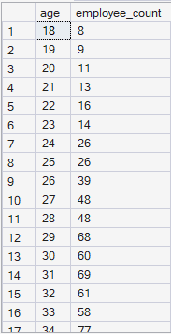

Education Field wise Attrition:
select education_field, count(attrition) as attrition_count from hrdata
where attrition='Yes'
group by education_field
order by count(attrition) desc;
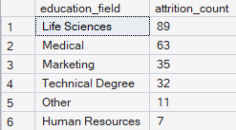
Attrition Rate by Gender for different Age Group
select age_band, gender, count(attrition) as attrition,
round((cast(count(attrition) as numeric) / (select count(attrition) from hrdata where attrition = 'Yes')) * 100,2) as pct
from hrdata
where attrition = 'Yes'
group by age_band, gender
order by age_band, gender desc;
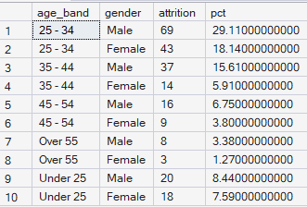

Job Satisfaction Rating
SELECT *
FROM
(
SELECT
job_role,
job_satisfaction,
employee_count
FROM hrdata
) AS source_table
PIVOT
(
SUM(employee_count)
FOR job_satisfaction IN ([1], [2], [3], [4])
) AS pivot_table
ORDER BY job_role;
